

**CIS020-1 – Introduction to Software Development**

**CIS093-1 – Mathematics and Concepts for Computational Thinking**

**Assignment 2 – Group / Individual Project –CaseStudy**

**(Taxi Booking System)**

**Student Name: Baibhav Paudel - 2146504X - University ID: 012345**

**Student Name: XXXX XXXXX - University ID: 012345**

**OR**

**Student Name: XXXX XXXXX - University ID: 012345**

**Table of Contents**

Introduction/Overview 5

Task Description 5

Assumptions about the system : 6

Assumptions about the system : 6

Project Plan/Schedule 6

Requirements Analysis 7

Functional Requirements 7

Functional Requirements 7

Non-functional Requirements 7

Non-functional Requirements 7

Usability Requirements 8

Usability Requirements 8

Design 8

UML Diagrams 8

UML Diagrams 8

Uses Case Diagrams(s) 9

Uses Case Diagrams(s) 9

Figure 1: Taxi_Booking_System_Usecase_diagram 9

Activity Diagram(s) 10

Activity Diagram(s) 10

Figure 2: Login_System_Activity_Diagram 10

Figure 3: Register_System_Activity_Diagram 10

11

11

Figure 4: Booking_System_Activity_Diagram 11

Figure 5: Admin_Control_System_Activity_Diagram 12

Class Diagram(s) 13

Class Diagram(s) 13

Figure 6: user_class_diagram 13

Figure 7: admin_class_diagram 13

Figure 8: taxi_class_diagram 14

Figure 9: driver_class_diagram 14

Figure 10: booking_class_diagram 15

Database Design 15

Database Design 15

15

15

Figure 11: turbo_tb_database_ERD 15

Logical Database Design 16

Logical Database Design 16

Figure 12: databae_ERM_figure 16

Physical Database Design 16

Physical Database Design 16

Skeleton Tables (with Primary Keys and Foreign Keys) 16

Skeleton Tables (with Primary Keys and Foreign Keys) 16

Data Dictionary 17

Data Dictionary 17

Table 1: user_data_dicrionary_table 17

Table 2: booking_data_dictionary_table 18

Table 3: admin_data_dictionary_table 19

Table 4: taxi_data_dictionary_table 19

Table 5: drivers_data_dictionary_table 20

User Interface Design 20

User Interface Design 20

Figure 13: homepage_interface_design 20

Figure 14: user_signup_interface_design 21

Figure 15: user_login_interface_design 21

Figure 16: user_dashboard_interface_design 22

Figure 17: user_profile_interface_design 22

Figure 18: booking_form_interface_design 23

Figure 19: admin_interface_design 23

Figure 20: booking_detail_admin_view_interface_design 24

Figure 21: driver_login_interface_design 24

Figure 22: driver_daashboard_interface_design 25

Algorithm Design 25

Algorithm Design 25

Implementation 28

Figure 23: home_page 29

Figure 24: signup_page 29

Figure 25: signup_page_with data 30

Figure 26: after_clicking_signup_button 30

Figure 27: login_page 31

Figure 28: login_page_with_data 31

Figure 29: user_dashboard 32

Figure 30: profile_page 32

Figure 31: admin_login 33

Figure 32: admin_dashboard 33

Figure 33: register_taxi 34

Figure 34: after_clicking_on_taxi_register 34

Figure 35: driver_register 35

Figure 36: driver_register_with_data 35

Figure 37: after_driver_is_registered 36

Figure 38: double_clicking_on_booking_request 36

Figure 39: after_clicking_on_cancel_booking 37

Figure 40: after_booking_is_canceled 37

Figure 41: after_clicking_on_assign_button 38

Figure 42: after_clicking_on_register 38

Figure 43: booking_detail_after_booking_is_accepted 39

Figure 44: driver_detail_after_booking_is_accepted 39

Figure 45: driver_login_page 40

Figure 46: driver_dashboard 40

Test No 41

Test Date 41

Purpose of test 41

Input data or action 41

Expected result 41

Actual result 41

Action if the above are not the same 41

Screenshot of output 41

CIS020-1 – Introduction to Software Development - 2021-2022

CIS093-1 – Mathematics and Concepts for Computational Thinking – 2021-2022  
Assignment 2 – Individual Project – Case Study (Taxi Booking System)

# Introduction/Overview

The Taxi Booking System project, together with the project brief and requirements to execute this assignment, was the final task handed to us. Our primary objective in order to finish Assignment 2 was to create a system for booking taxis. In order to book a cab, a user must first register and sign in using login information (username and password), hence a user registration system and a user login system were created. There must be a way for the system user to reserve a taxi for their journey, thus a booking system was developed. A mechanism for admin control was created to allocate cabs to user booking requests. A driver dashboard was established where he or she could monitor assigned bookings, mark them as completed when the journey was finished, and view forthcoming bookings. A database was made and the system was connected to it using a database connector in order to keep all of the user information and details in the system.

# Task Description

The main aim was to create software for a taxi company so that customers could schedule cabs and view their upcoming journeys online using a desktop application's graphical user interface. All the important data regarding user, booking, taxi, and the driver had to be kept in an external database system.

The user must first register as a user with accurate information in order to make a cab reservation. After registering, the user must be able to input the location, date, and time of their pickup as well as the destination of their journey throughout the booking process.

The system must have a capability that allows users to update or cancel their reservations and view forthcoming trips through a graphical user interface. Admin from the business side must

be allowed to approve the user's booking once they submit it and choose a taxi driver to complete the booking. Each driver must have a single forthcoming trip.

## Assumptions about the system :

* The cost of a journey is determined during the booking process based on the distance between the pickup place and the destination.
* Credit card payments will be added in the driver's account balance.
* The driver is paid immediately once the journey is finished.
* Even after cabs have been assigned, reservations can still be canceled, but only with the admin's permission if an issue occurs.
* Taxi assignments cannot be changed.
* The driver keeps his or her earnings throughout the month, but at the end of the month, he or she is required to pay the corporate service fee which has already been computed and is shown to him in his driver dashboard in order to continue using the system the following month.

# Project Plan/Schedule

|  |  |  |
| --- | --- | --- |
| Week No. | Tasks | Priority |
|  |  |  |
|  |  |  |
|  |  |  |
|  |  |  |
|  |  |  |
|  |  |  |
|  |  |  |
|  | Submit Group Report, Project Code and Video Recording (if required) |  |
|  | Project Presentation (if required) |  |

# Requirements Analysis

## Functional Requirements

TTBS = Turbo Taxi Booking System

|  |  |  |
| --- | --- | --- |
| Req. No | Requirement | Priority* |
| 1 | A signup system allows customers to register. | MUST |
| 2 | To access the system, users must log in. | MUST |
| 3 | Request booking from booking form. | MUST |
| 4 | User and reservation information is saved to a separate file. | MUST |
| 5 | An administrator must be able to add a cab to a user's reservation. | MUST |
| 6 | All booking requests will be visible to the administrator. | MUST |
| 7 | Bookings must be able to be canceled by admin. | MUST |
| 8 | The user must be able to see information about forthcoming bookings. | MUST |
| 9 | A booking must be able to be cancelled by the user. | MUST |
| 10 | Booking specifics must to be editable by the user. | SHOULD |
| 11 | he ability to log into the system is required for cab drivers. | MUST |
| 12 | An forthcoming journey must be visible to taxi drivers. | MUST |
| 13 | It should be possible for taxi drivers to see their earnings. | SHOULD |

## Non-functional Requirements

|  |  |  |
| --- | --- | --- |
| Req. No | Requirement | Priority* |
| 1 | The system's processing speed should be high. | MUST |
| 2 | Must be screen-adaptive for devices. | SHOULD |
| 3 | System upgrades must be possible. | MUST |
| 4 | must be free of crashes or run-time problems. | MUST |

## Usability Requirements

|  |  |  |
| --- | --- | --- |
| Req. No | Requirement | Priority* |
| 1 | System GUI must be user friendly. | MUST |
| 2 | All forms for entering data should be brief, simple to complete, and include entry validation. | MUST |

# Design

## UML Diagrams

### Uses Case Diagrams(s)

Figure 1: Taxi_Booking_System_Usecase_diagram

### Activity Diagram(s)

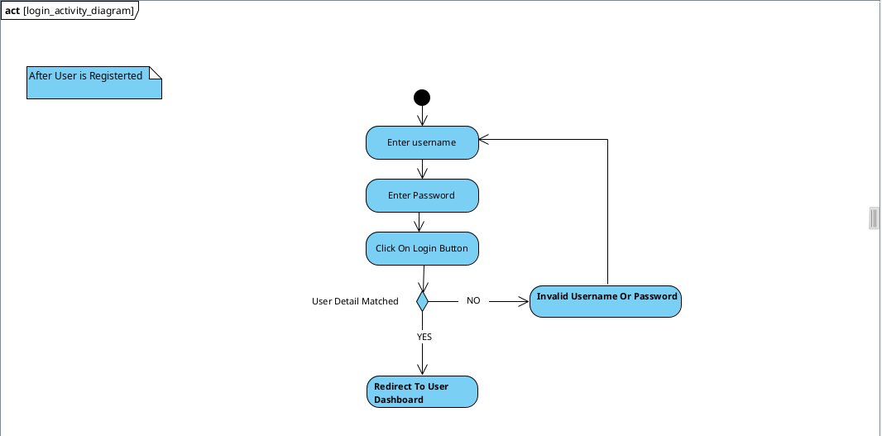Figure 2: Login_System_Activity_Diagram

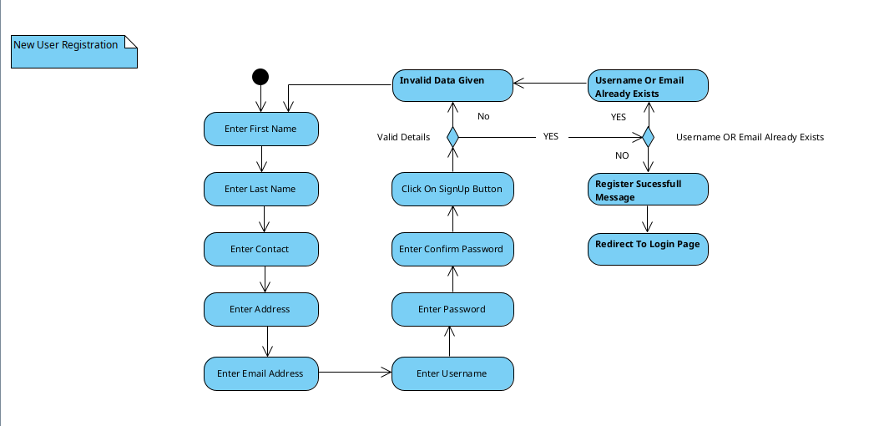Figure 3: Register_System_Activity_Diagram

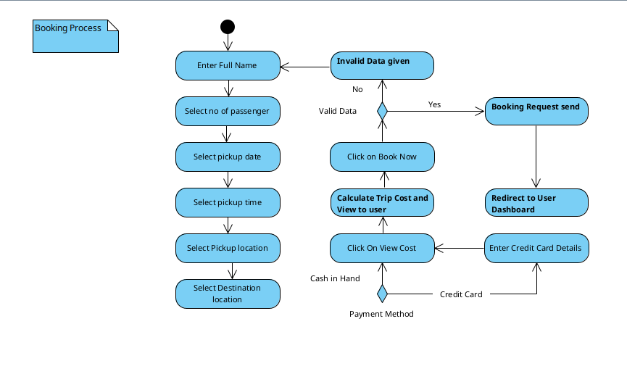Figure 4: Booking_System_Activity_Diagram

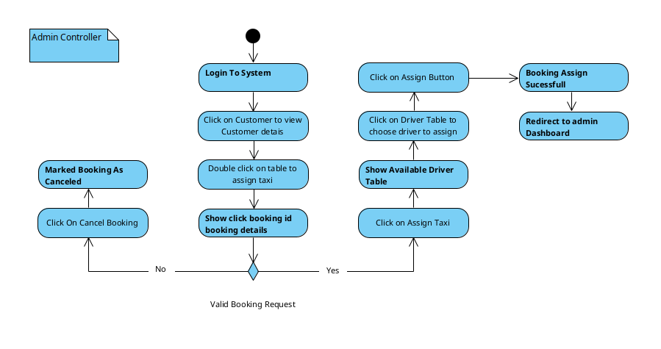Figure 5: Admin_Control_System_Activity_Diagram

### Class Diagram(s)

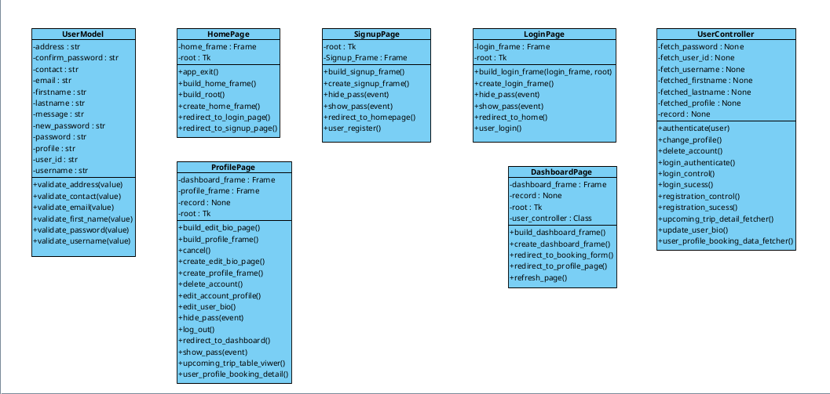Figure 6: user_class_diagram

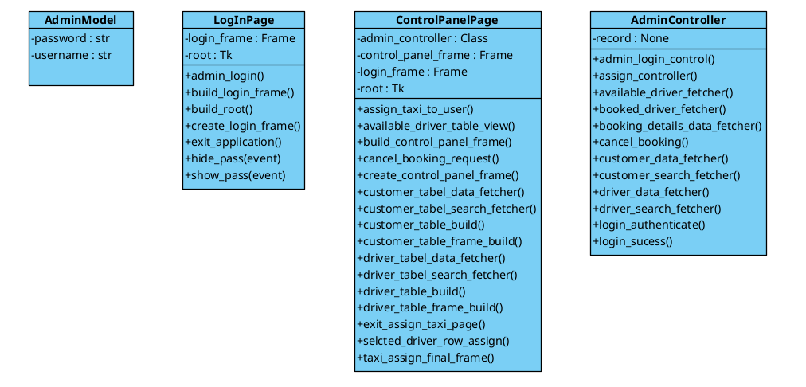Figure 7: admin_class_diagram

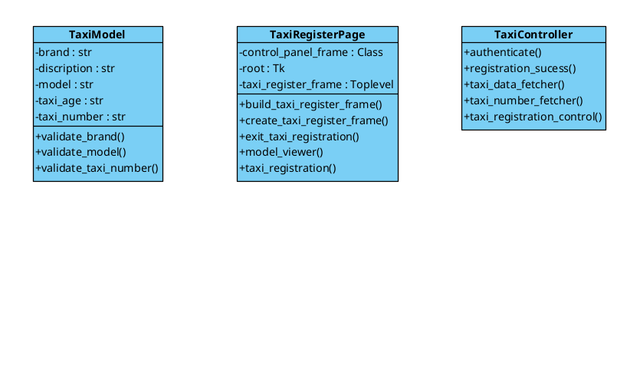Figure 8: taxi_class_diagram

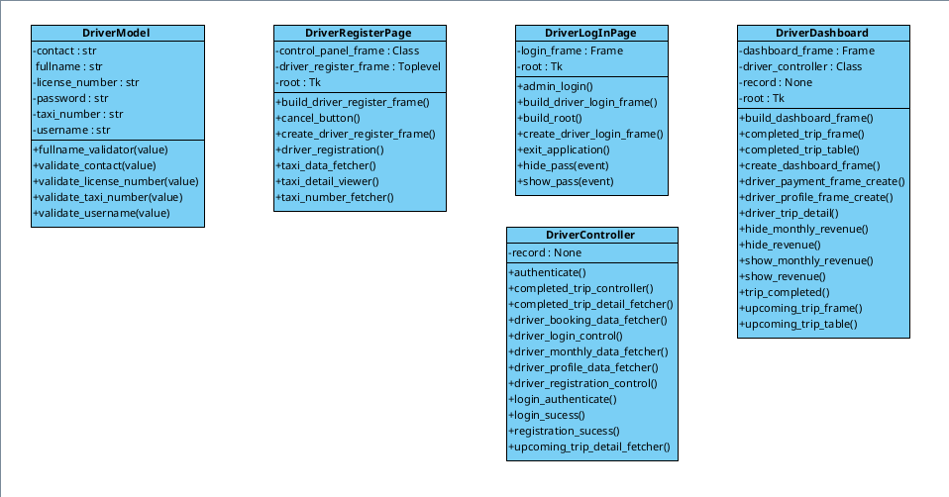Figure 9: driver_class_diagram

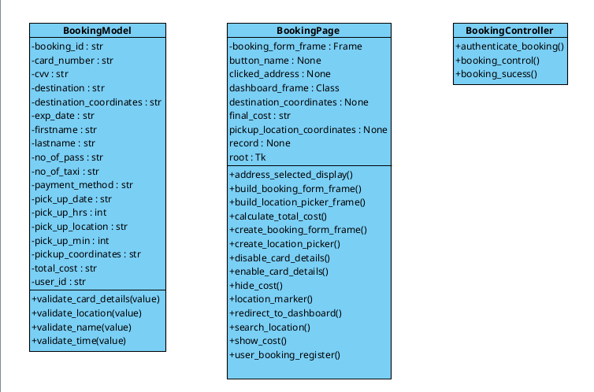Figure 10: booking_class_diagram

## Database Design

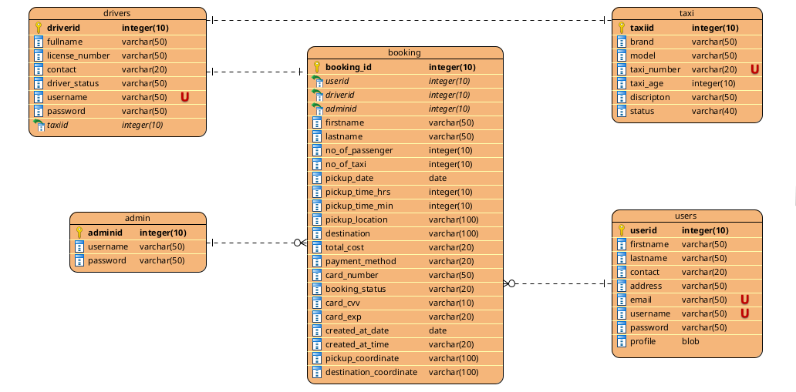Figure 11: turbo_tb_database_ERD

### Logical Database Design

Figure 12: databae_ERM_figure

### Physical Database Design

#### Skeleton Tables (with Primary Keys and Foreign Keys)

Users(**userid**, firstname, lastname, contact, address, email, username,

password, profile)

Booking (**booking_id**, userid*, driverid*, adminid*, firstname,lastname, no_of_passenger, no_of_taxi, pickup_date, pickup_time_hrs, pickup_time_min, pickup_location, destination, total_cost, payment_method, card_number, booking_status, card_cvv, card_exp, created_at_date, created_at_time, pickup_coordinates, destination_coordinates)

Taxi (**taxiid**, brand, model, taxi_number, taxi_age, discription, status)

driver (**driverid**, fullname, license_number, contact, driver_status, username, password, taxiid*)

Admin (**adminid**, username, password)

#### Data Dictionary

Table 1: user_data_dicrionary_table

|  |  |  |  |  |  |
| --- | --- | --- | --- | --- | --- |
| **Users** | | | | | |
| **Discription :** Users Details | | | | | |
| **Field Name** | **Data Type** | **Length** | **Index** | **Null** | **Discription** |
| **Userid**  **(Primary)** | **int** | **10** | **PK** | **No** | **Auto Increment** |
| **firstname** | **varchar** | **50** |  | **No** | **Firstname of user** |
| **lastname** | **varchar** | **50** |  | **N0** | **Lastname of user** |
| **contact** | **varchar** | **20** |  | **No** | **Contact detail of user** |
| **address** | **varchar** | **50** |  | **No** | **User’s location detail** |
| **email** | **varchar** | **50** | **U** | **No** | **Valid email address of user** |
| **username** | **varchar** | **50** | **U** | **No** | **Username for login** |
| **password** | **varchar** | **50** |  | **No** | **Password for personal security** |
| **profile** | **blob** |  |  | **No** | **User’s profile picture** |

Table 2: booking_data_dictionary_table

|  |  |  |  |  |  |
| --- | --- | --- | --- | --- | --- |
| **Booking** | | | | | |
| **Discription :** Booking details made by user | | | | | |
| **Field Name** | **Data Type** | **Length** | **Index** | **Null** | **Discription** |
| **booking_id**  **(Primary)** | **int** | **10** | **PK** | **No** | **Auto Increment** |
| **userid** | **int** | **10** | **Fk** | **No** | **User table foreign key** |
| **driverid** | **int** | **10** | **Fk** |  | **drivers table foreign key** |
| **adminid** | **int** | **10** | **Fk** |  | **admin table foreign key** |
| **firstname** | **varchar** | **50** |  | **No** | **User’s first name** |
| **lastname** | **varchar** | **50** |  | **No** | **User’s last name** |
| **no_of_passenger** | **int** | **50** |  | **No** | **No of passenger in a trip** |
| **pickup_date** | **date** | **50** |  | **No** | **Date for the pickup** |
| **pickup_time_hrs** | **int** | **10** |  | **No** | **Time for the pickup HRS** |
| **pickup_time_min** | **int** | **10** |  | **No** | **Time for the pickup MIN** |
| **pickup_location** | **varchar** | **100** |  | **No** | **Location to pickup** |
| **destination** | **varchar** | **100** |  | **No** | **Final destination of trip** |
| **total_cost** | **varchar** | **20** |  | **No** | **Total cost to be paid** |
| **payment_method** | **varchar** | **20** |  | **No** | **Method of payment** |
| **card_number** | **varchar** | **50** |  |  | **Credit card number** |
| **card_cvv** | **varchar** | **20** |  |  | **Credit card cvv** |
| **card_exp** | **varchar** | **10** |  |  | **Credit card exp date** |
| **created_at_date** | **date** |  |  | **No** | **Booking created date** |
| **created_at_time** | **varchar** | **20** |  | **No** | **Booking created time** |
| **pickup_coordinates** | **varchar** | **100** |  | **No** | **Pickup location coordinates** |
| **destination_coordinates** | **varchar** | **100** |  | **No** | **Destination coordinates** |
| **booking_status** | **varchar** | **20** |  | **No** | **Status of booking request** |

Table 3: admin_data_dictionary_table

|  |  |  |  |  |  |
| --- | --- | --- | --- | --- | --- |
| **Admin** | | | | | |
| **Discription :** Admin Details | | | | | |
| **Field Name** | **Data Type** | **Length** | **Index** | **Null** | **Discription** |
| **adminid**  **(Primary)** | **int** | **10** | **PK** | **No** | **Auto Increment** |
| **username** | **varchar** | **50** |  | **No** | **Username to login to system** |
| **password** | **varchar** | **50** |  | **N0** | **Account password** |

Table 4: taxi_data_dictionary_table

|  |  |  |  |  |  |
| --- | --- | --- | --- | --- | --- |
| **Taxi** | | | | | |
| **Discription :** Taxi Details | | | | | |
| **Field Name** | **Data Type** | **Length** | **Index** | **Null** | **Discription** |
| **taxiid**  **(Primary)** | **int** | **10** | **PK** | **No** | **Auto Increment** |
| **brand** | **varchar** | **50** |  | **No** | **Brand of a taxi** |
| **model** | **varchar** | **50** |  | **N0** | **Model of a taxi brand** |
| **taxi_number** | **varchar** | **20** |  | **No** | **Taxi number** |
| **taxi_age** | **int** | **10** |  | **No** | **Used time of taxi** |
| **discription** | **varchar** | **50** |  | **No** | **Details about taxi** |
| **status** | **varchar** | **40** |  | **No** | **Taxi assign status** |

Table 5: drivers_data_dictionary_table

|  |  |  |  |  |  |
| --- | --- | --- | --- | --- | --- |
| **Drivers** | | | | | |
| **Discription :** Drivers Details | | | | | |
| **Field Name** | **Data Type** | **Length** | **Index** | **Null** | **Discription** |
| **driverid**  **(Primary)** | **int** | **10** | **PK** | **No** | **Auto Increment** |
| **fullname** | **varchar** | **50** |  | **No** | **Firstname of driver** |
| **license_number** | **varchar** | **50** |  | **N0** | **Lastname of driver** |
| **contact** | **varchar** | **20** |  | **No** | **Contact detail of driver** |
| **driver_status** | **varchar** | **50** |  | **No** | **Driver’s assign status** |
| **username** | **varchar** | **50** | **U** | **No** | **Username for login** |
| **password** | **varchar** | **50** | **U** | **No** | **Password for personal security** |
| **taxiid** | **int** | **10** | **FK** | **No** | **Foreign key from taxi table** |

## User Interface Design

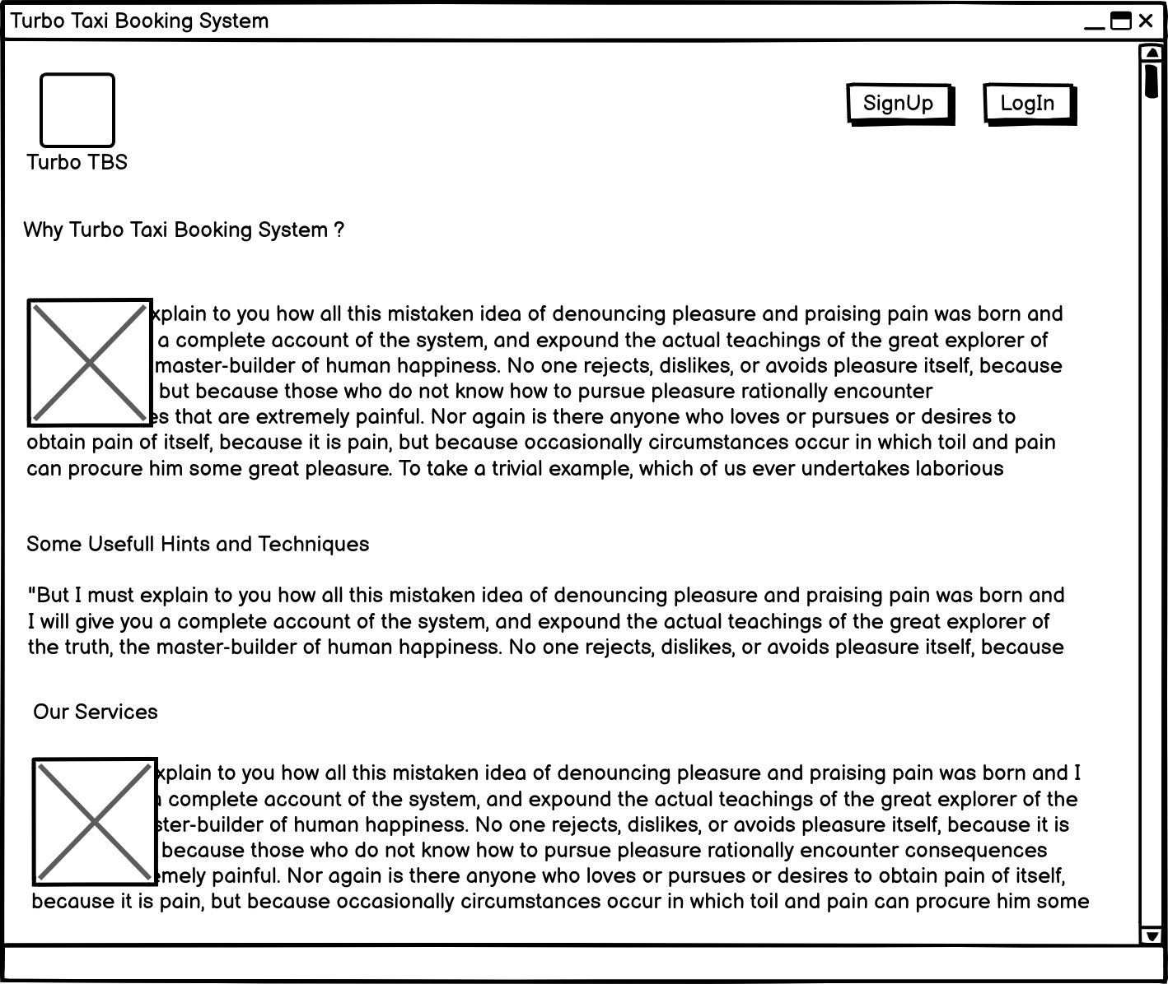Figure 13: homepage_interface_design

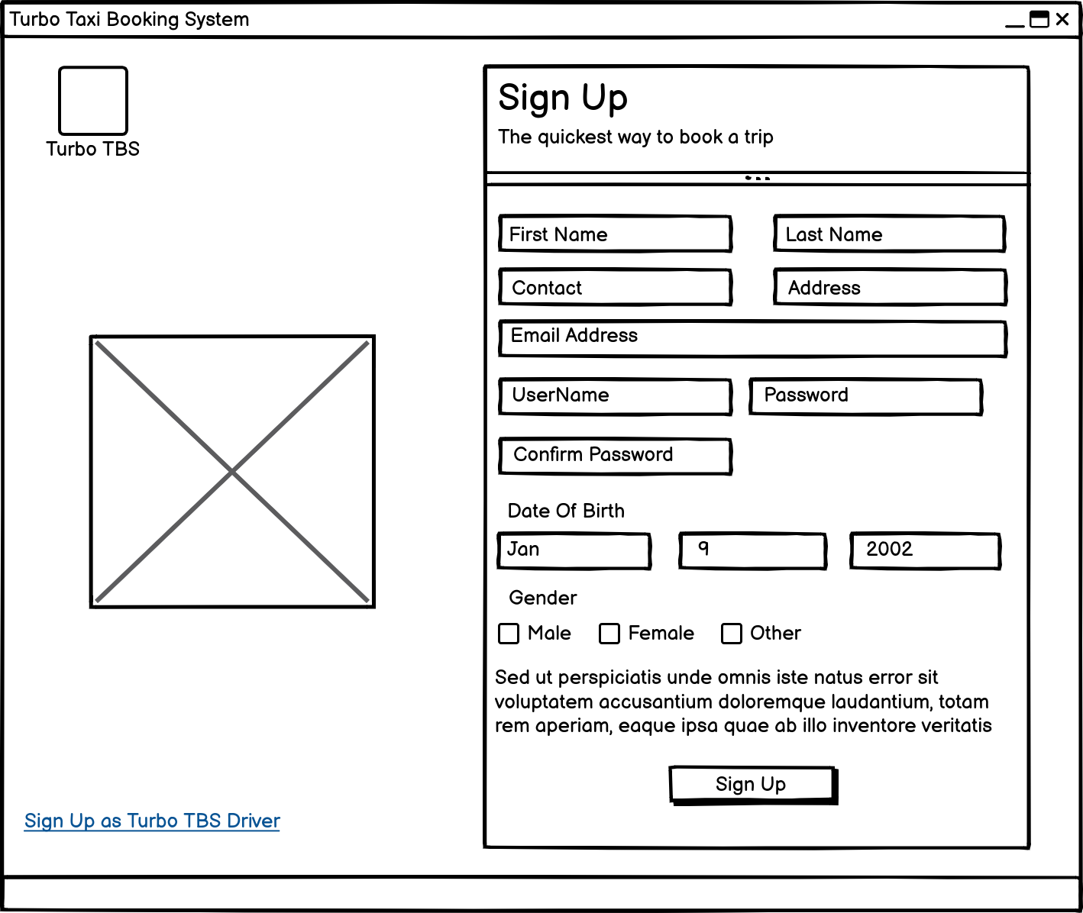Figure 14: user_signup_interface_design

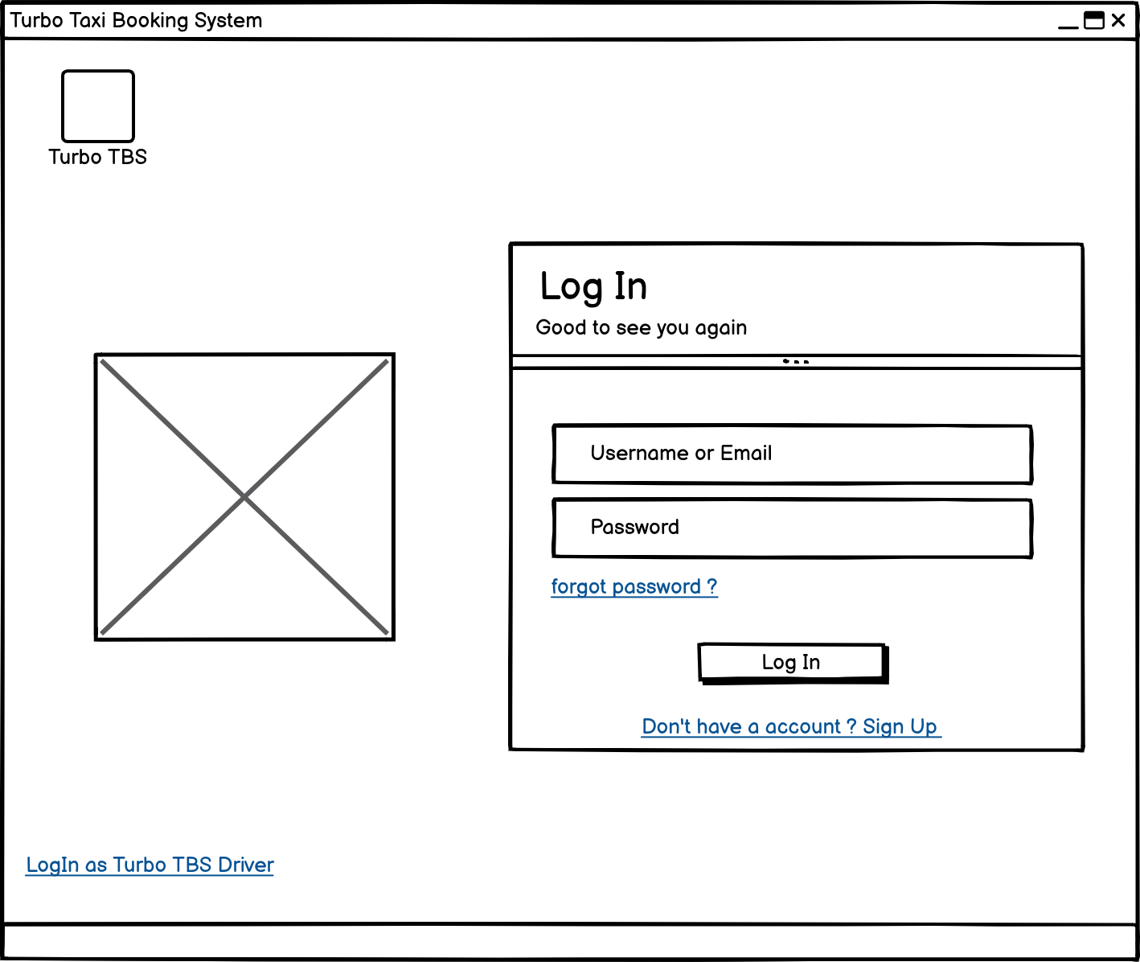Figure 15: user_login_interface_design

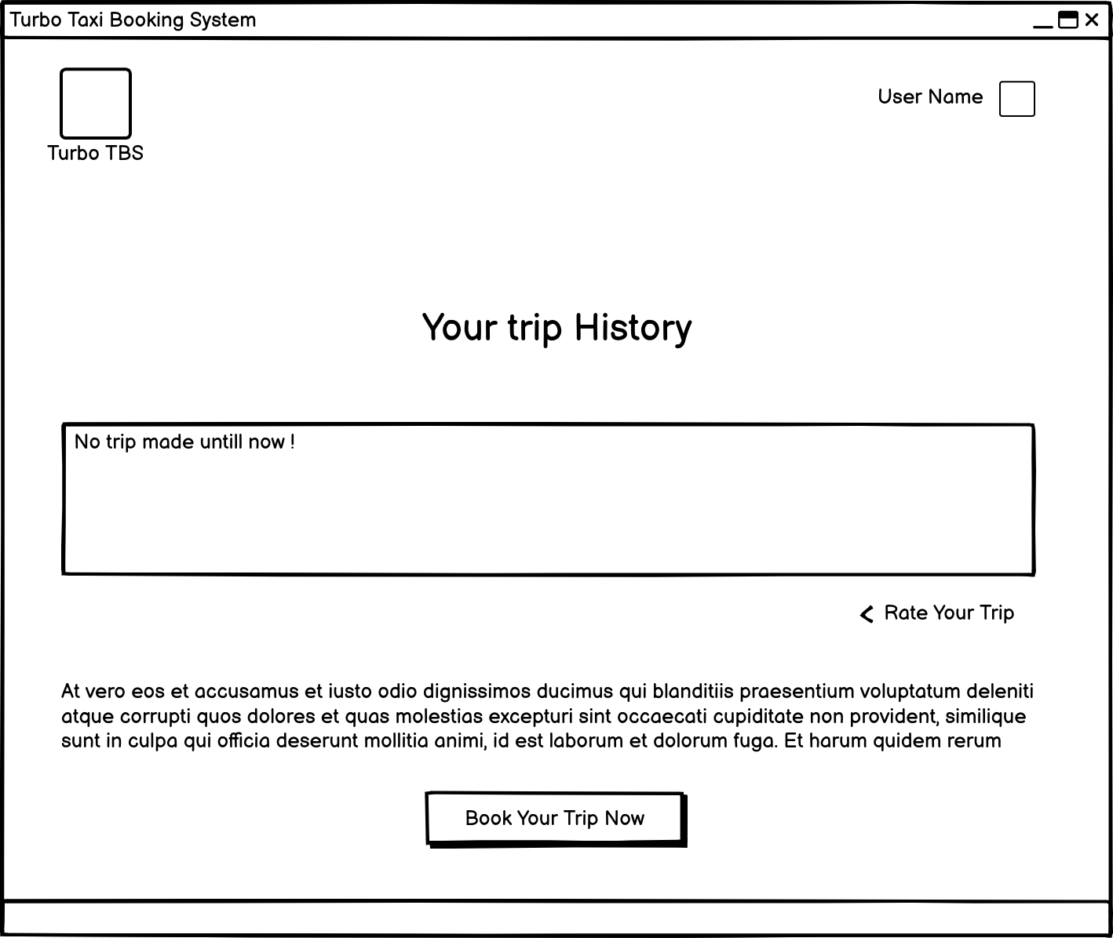Figure 16: user_dashboard_interface_design

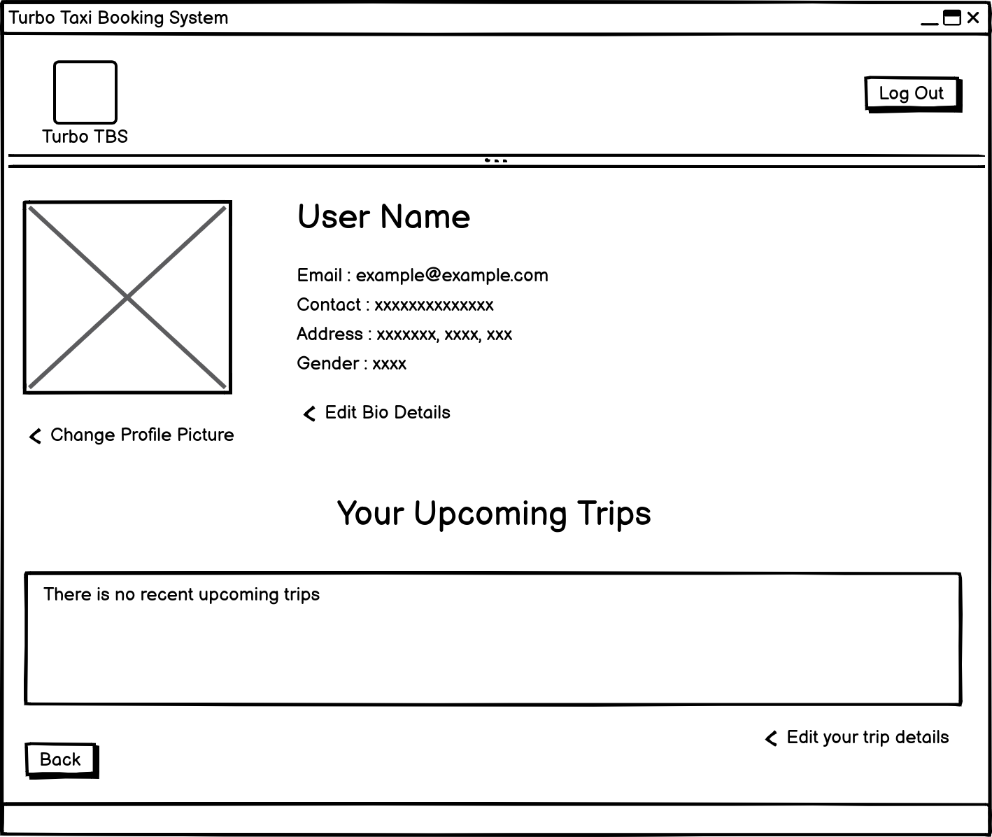Figure 17: user_profile_interface_design

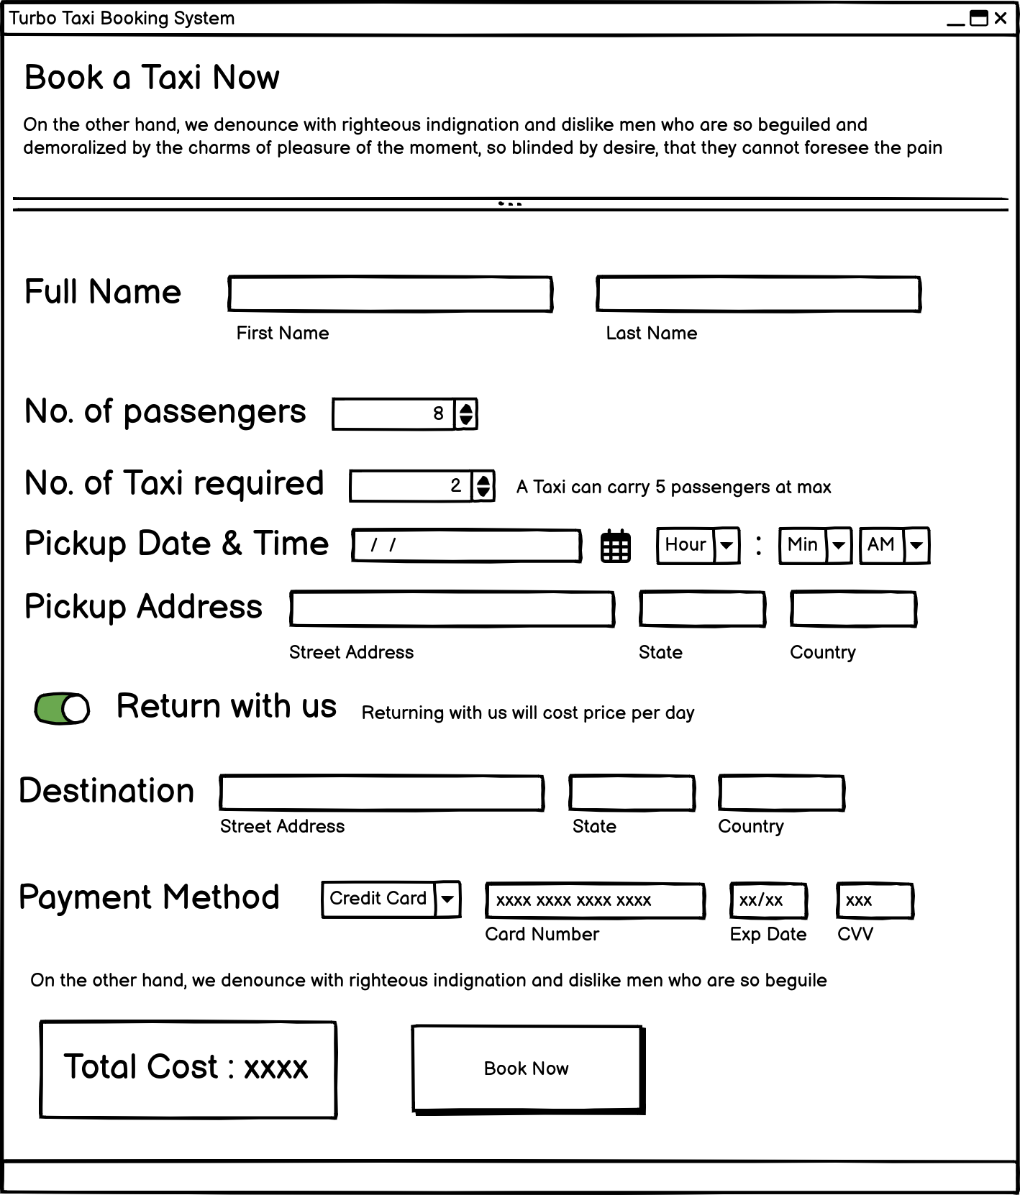Figure 18: booking_form_interface_design

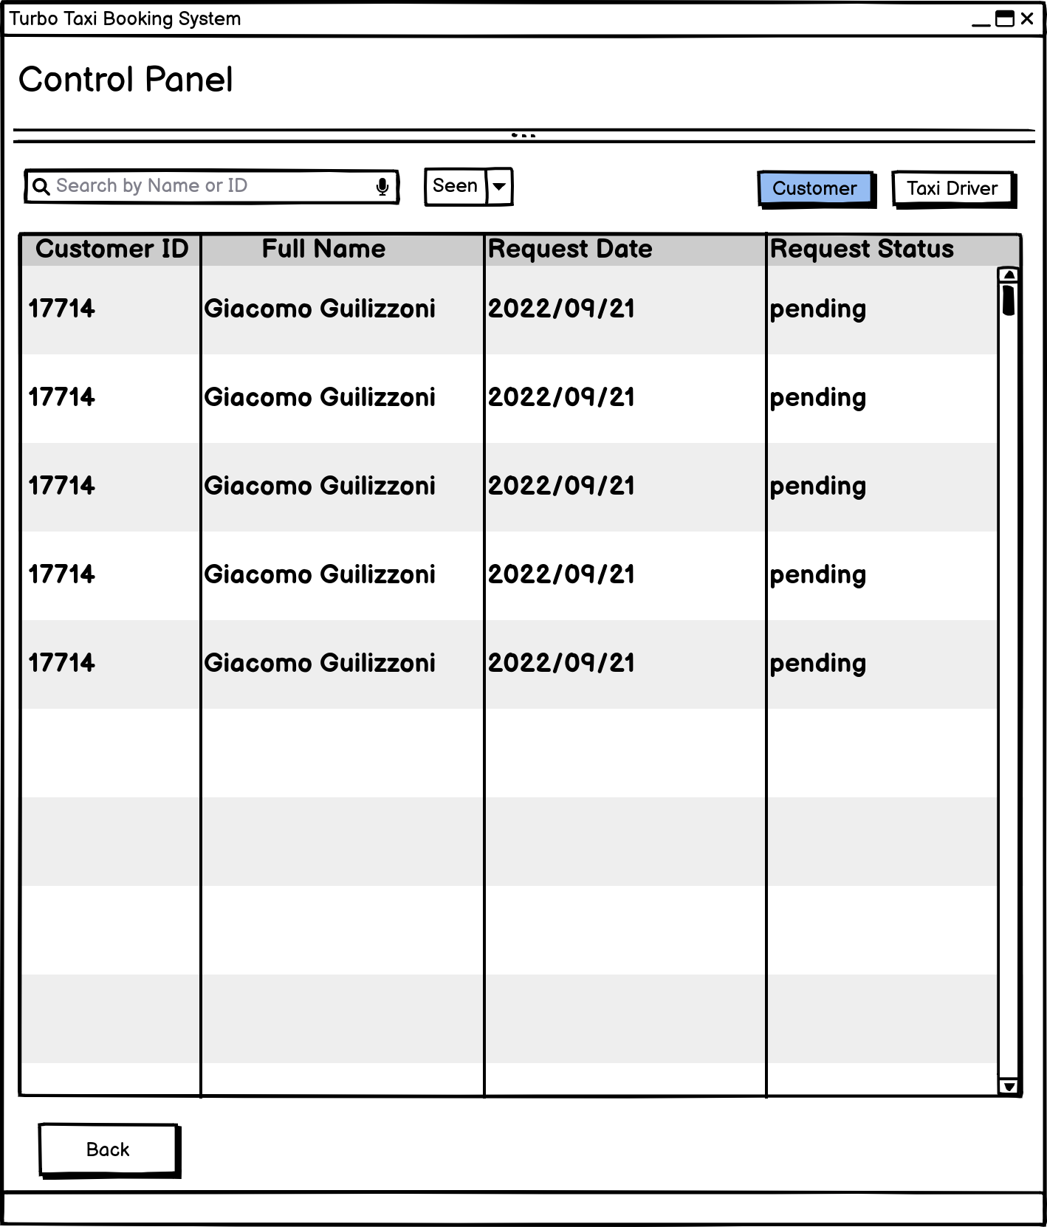Figure 19: admin_interface_design

## 

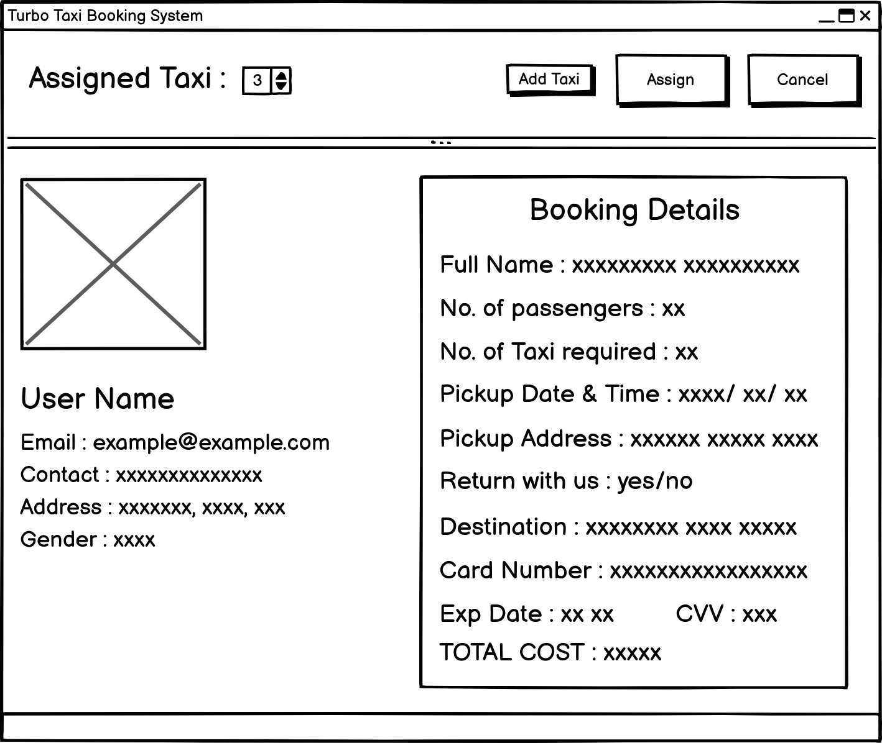Figure 20: booking_detail_admin_view_interface_design

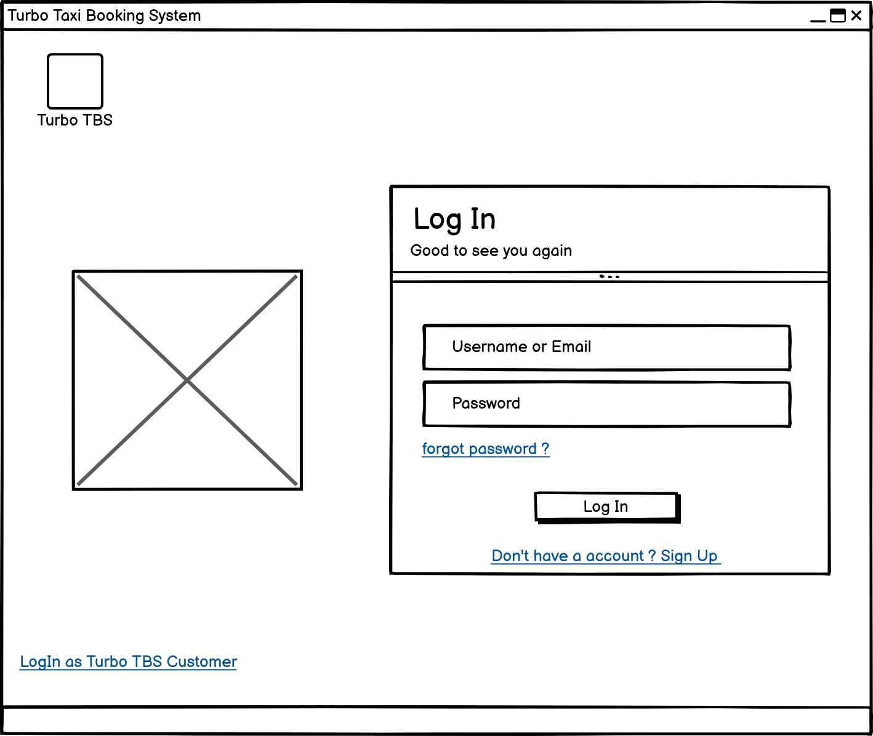Figure 21: driver_login_interface_design

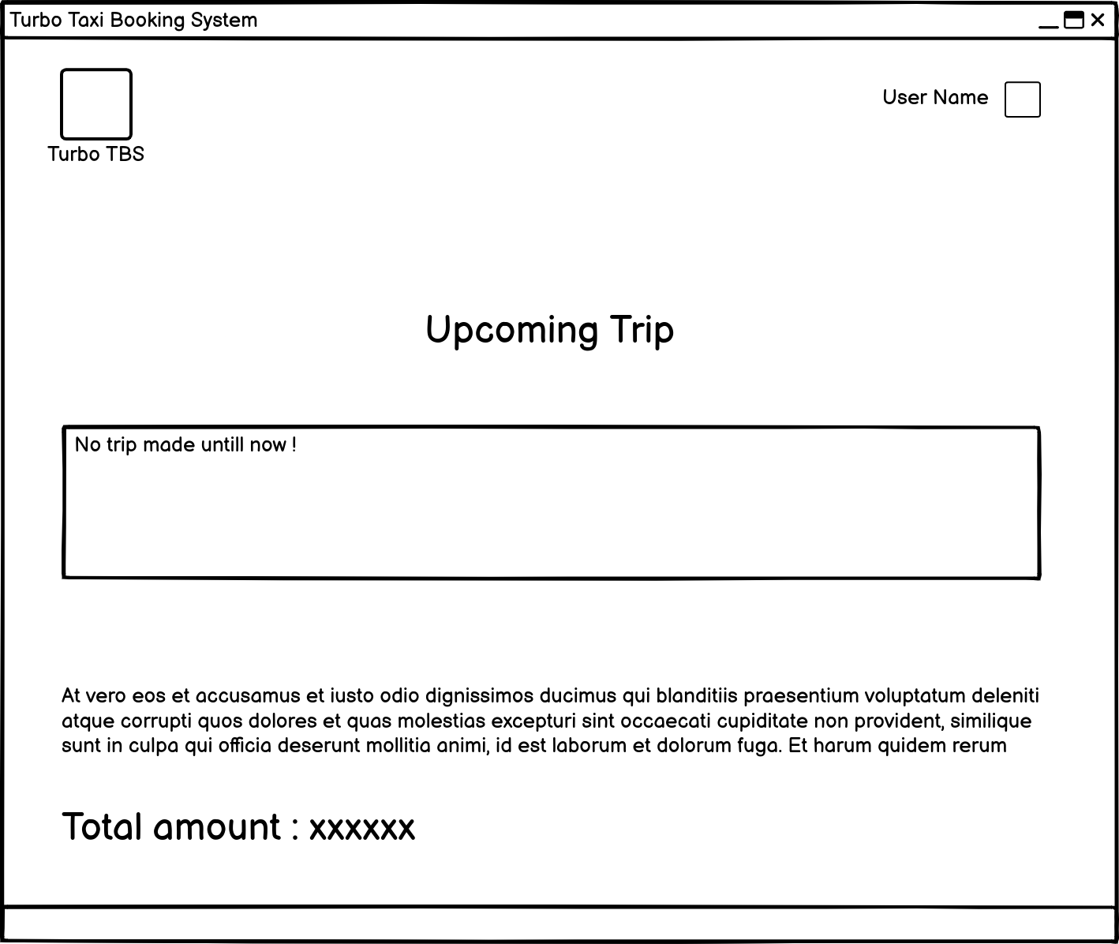Figure 22: driver_daashboard_interface_design

## Algorithm Design

Flow of the development process

• Flow of the system hierarchy

Taxi booking system

• The system :

Main dashboard : SignUp and SignIn on the main dashboard, with a visible working gallery

1. After clicking SignUp, "SignUp as Customer" will open up and also provide a link for "SignUp as Worker."
2. Both forms will require different information and will be saved on different tables of the database.
3. After clicking Sign In, the Sign In as Customer page will appear, along with a link to Sign In as Worker.
4. The same information will be required for both forms. username, email, and password

type of user

i. Customer ( The one who does the booking action ) :

Working of a customer :

1. Register as a customer

2. Sign up with all the required details.

3. If all the validation is completed, the user will be redirected to the login page.

4. The user will login with the given login email or username and password.

5. The user will be redirected to the user dashboard, which contains a "book now" button, a profile picture, a profile name, and some other details about the system (a hint).

6. Clicking on "Book Now" will redirect the user to the booking form.

7. After entering all of the necessary information, the user can click the Book button, which sends a booking request to the taxi company for approval.

8. This will redirect the user to their dashboard.

9. By clicking on the profile picture or the username on the dashboard, users will be redirected to the profile page.

10. Profile page will include all the previous booking history and ongoing booking information

11. The profile page will allow you to edit the booking details as well as your personal information.

12. The GUI must be good, as each function should change the pages for each different function.

13. Bookings can be canceled from the profile page until the trip date is more than one day away.

14. The completed trip can be seen, and the driver can be rated afterward.

ii . Admin (The one who assign the taxi and driver to the request trip)

Working of a Admin :

1. Log in as an administrator with the provided username and password.

2. Admin should be redirected to the admin dashboard.

3. The portal should contain two options (a taxi driver control panel and a customer booking request control panel).

4. Clicking on "Taxi Driver" (this will bring up a list of all registered taxi drivers as well as all taxi drivers who wanted to register with valid information).

5. It will also provide all the information about the taxi driver after clicking the taxi driver's name on an ID-sized card.

6. It will give the administrator full authority to accept or decline a registration request for a taxi driver after documentation review.

7. Admin will be able to go back to the previous page where they can select between the driver and the customer control panel with a back button.

8. Clicking on "customer" (it will provide a list of all the customers, and you can view their details by clicking their name, which will pop up an ID-type UI) 9. You can view the booking request made by the customer.

10. You can see the drivers that are already booked for a trip and the available taxi drivers that are suitable for the trip.

11. To accept a trip, click on a requested customer name, an Id type UI pops up, and then click on assign taxi after checking the requested booking detail (number of taxi will allow you to input number of taxi vehicle number with add button).

12. The "booking for Customer XXXXX has been completed" message will be shown, and then the pop-up will close on its own.

13. Admin have full authority to accept or decline an offer if it seems reasonable.

14. Admin can ban a registered user or a driver if they are found breaking the rules of an organization.

iii . Driver (The One who are assigned for customer to complete the trip)

Working of Driver :

1. Sign up as a driver

2. Sign up with all the details (full name, address, contact information, gender, date of birth, username, email address, experience, upload of a license photo up to 25 MB, vehicle number, vehicle registration number).

3. If all the validation is completed, the user will be redirected to the login page.

4. The user will login with the given login email or username and password.

5. The user will be redirected to the user dashboard.

6. The driver dashboard contains total income, upcoming trips, some information for easy use, Profile Page

7. By clicking on the profile picture or the username on the dashboard, the user will be redirected to the profile page.

8. The profile page will include all the previous booking history and personal details.

9. After the trip is assigned to the driver, the driver must take the trip as the company requests, but if the driver is not available, the driver can change the status from "available" to "not available."

10. Changing the status will affect the admin page, so the filter won't show the driver as an available driver, and assigning the tax trip to such a driver is not allowed.

# Implementation

How was the program created?

You should describe the development stages.

Using a Tkinter-based GUI, users of the Turbo Cab Booking System can request a taxi and calculating fares for the journey. Users may transmit or request data via a graphical user interface and a client server infrastructure, which allows for easy data sharing. With only one click, the user may use an external database system rather than using user storage to save data in the booking system. In addition, drivers have access to a list of their allocated travels, which are marked as finished when finished.

Data was stored in a PostgreSQL database, and psycopg2 was utilized as a connector between the system and the database. For frontend development, Tkinter, a built-in Python module, was used.

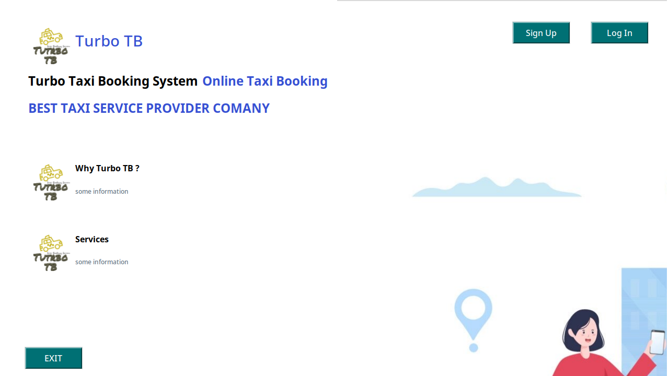Figure 23: home_page

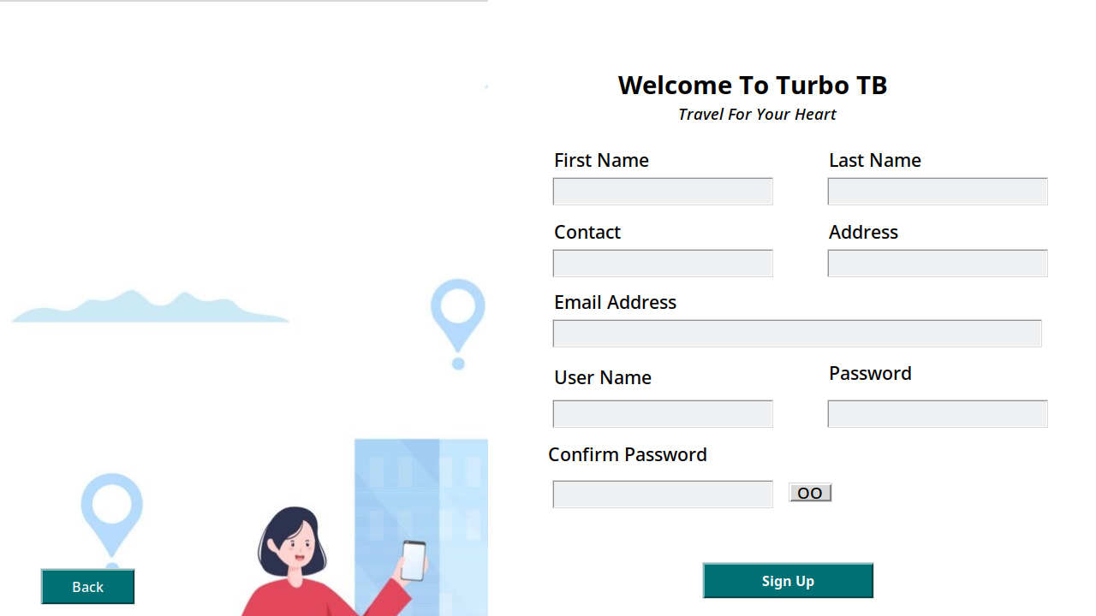Figure 24: signup_page

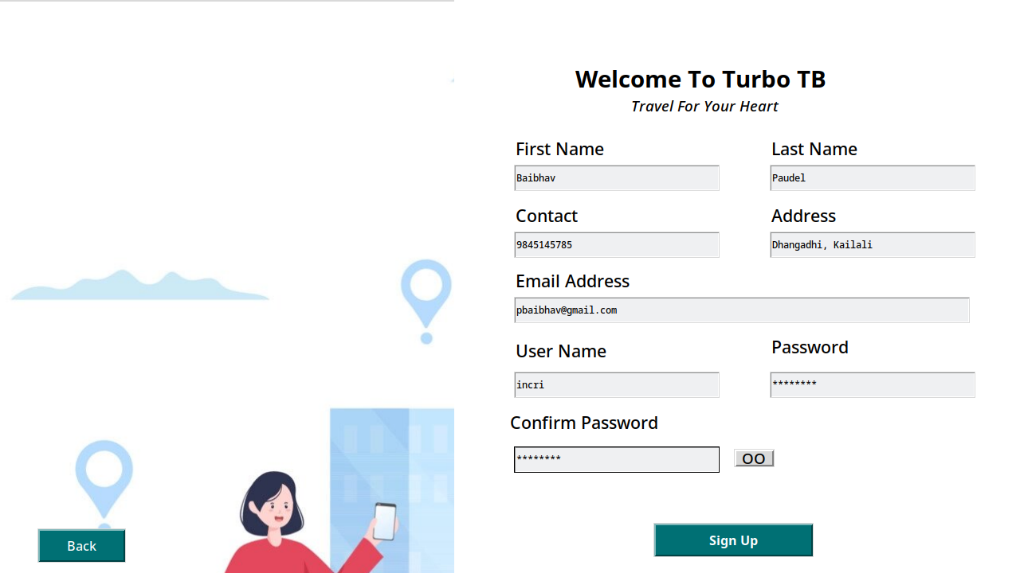Figure 25: signup_page_with data

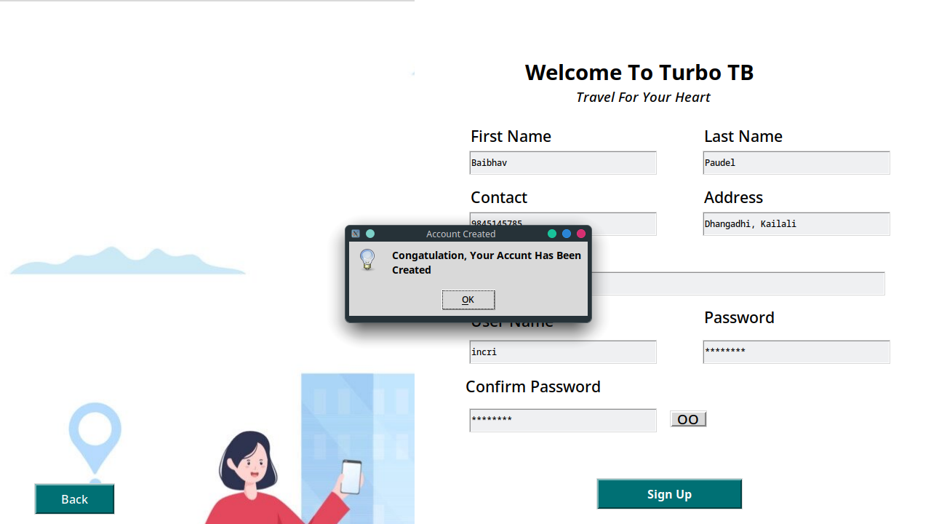Figure 26: after_clicking_signup_button

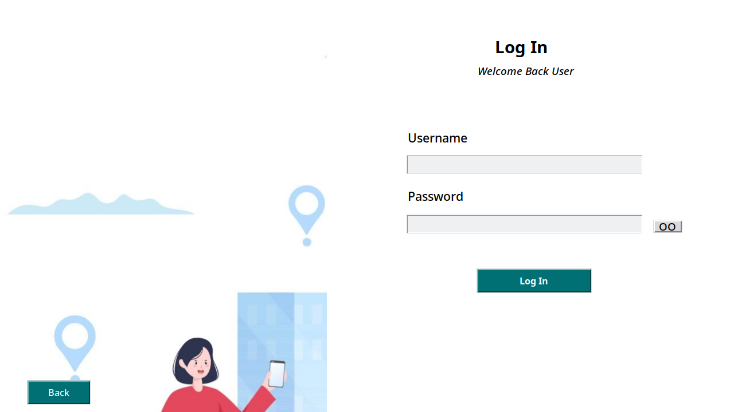Figure 27: login_page

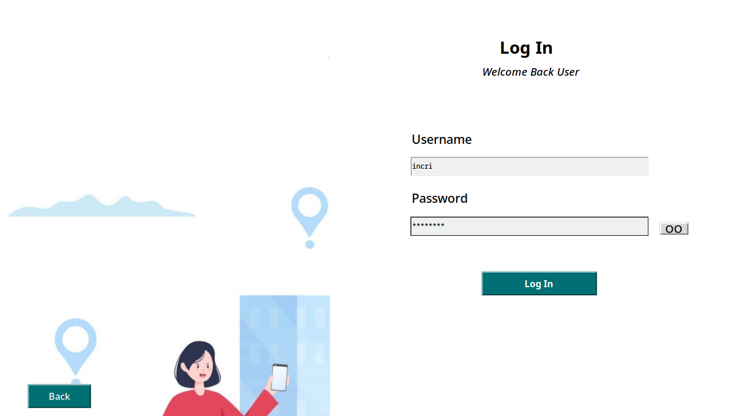Figure 28: login_page_with_data

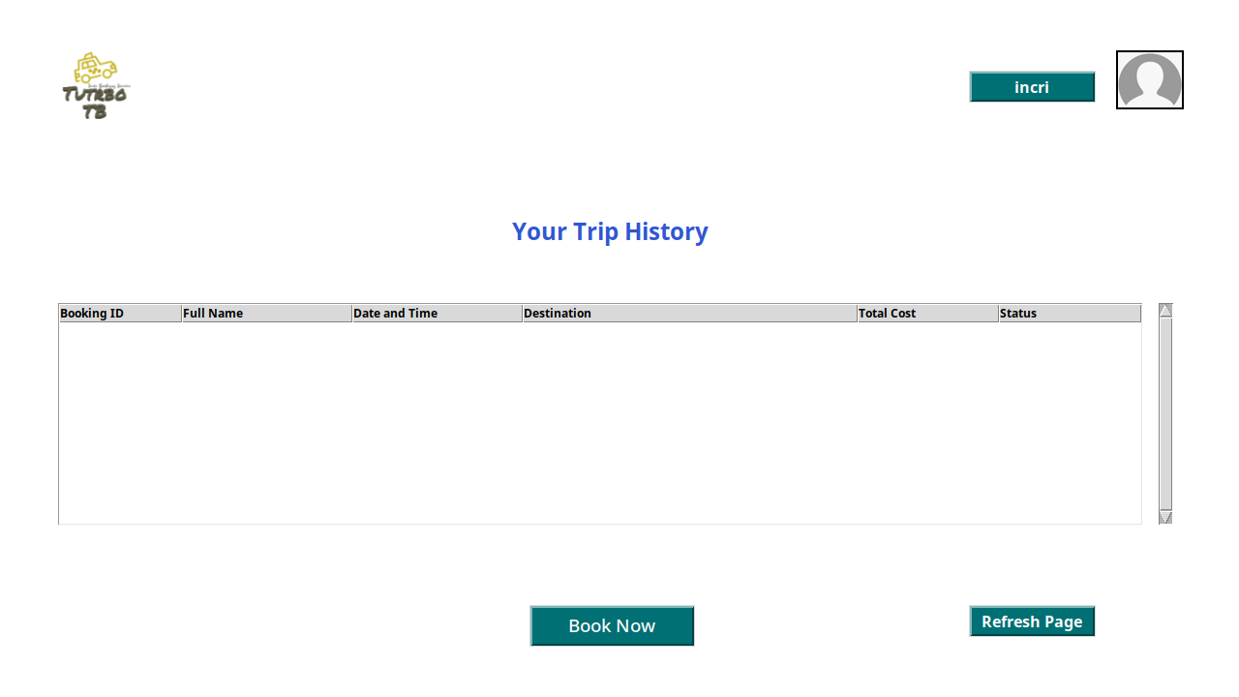Figure 29: user_dashboard

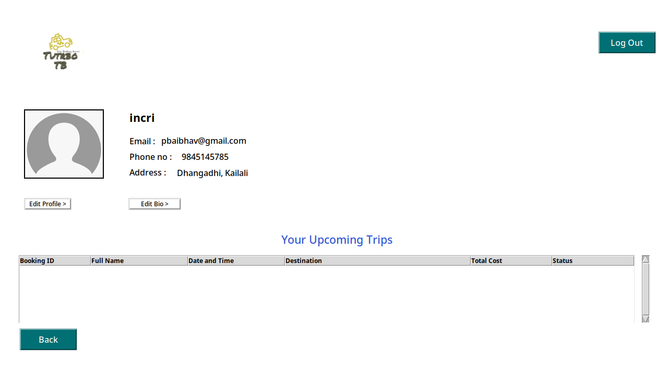Figure 30: profile_page

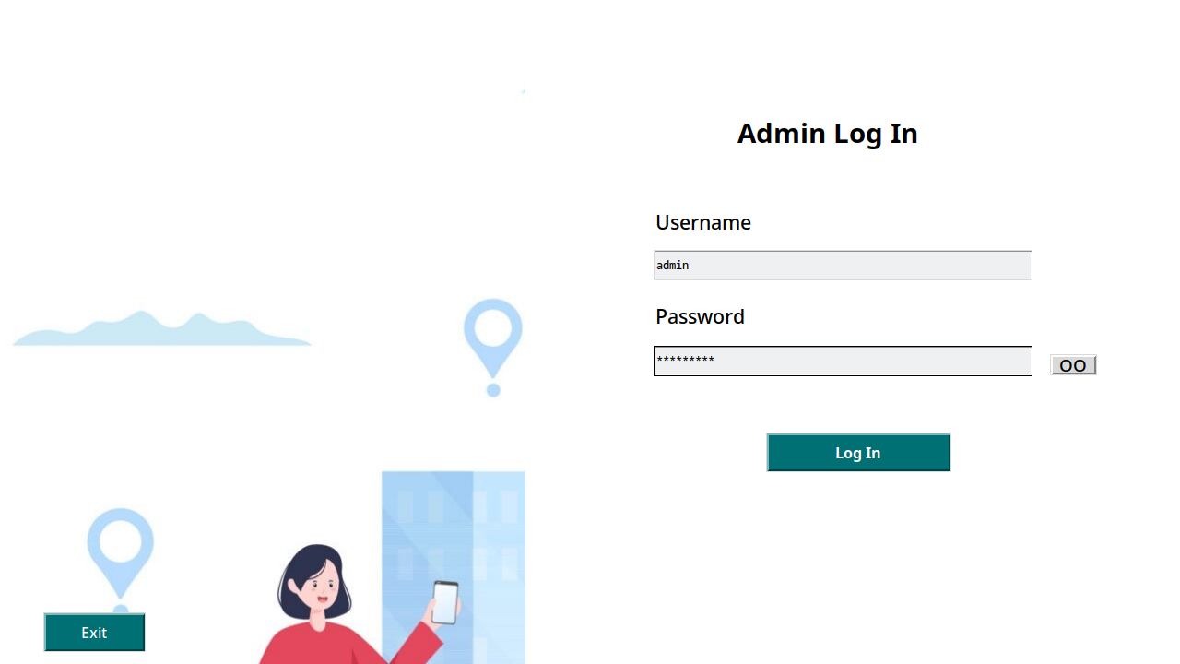Figure 31: admin_login

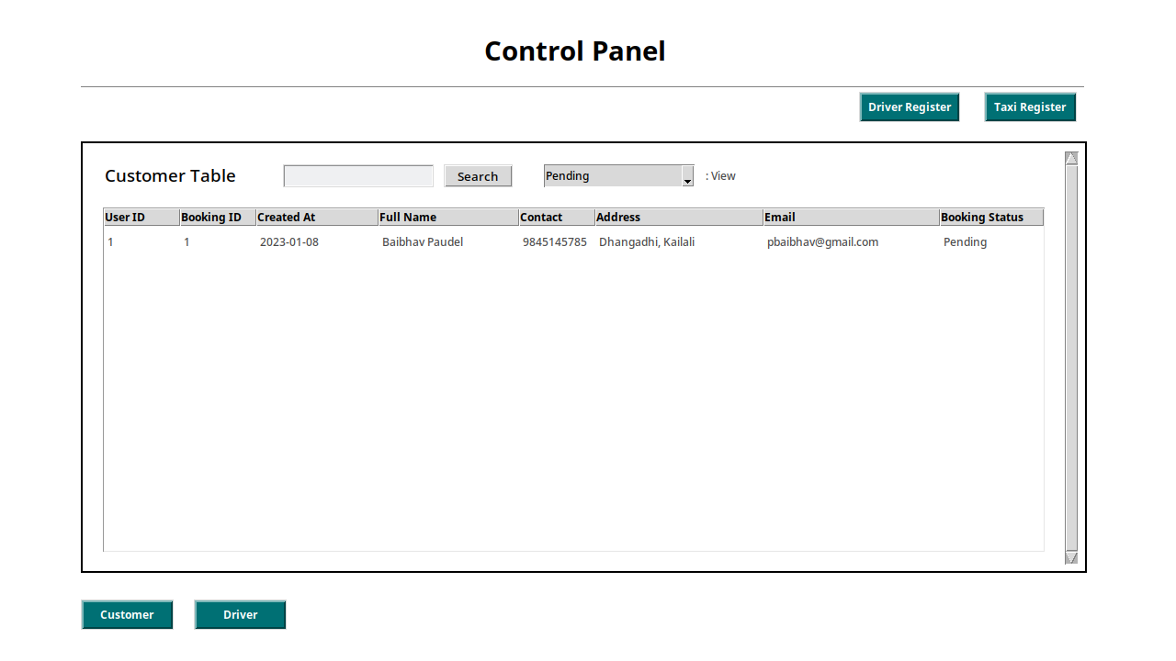Figure 32: admin_dashboard

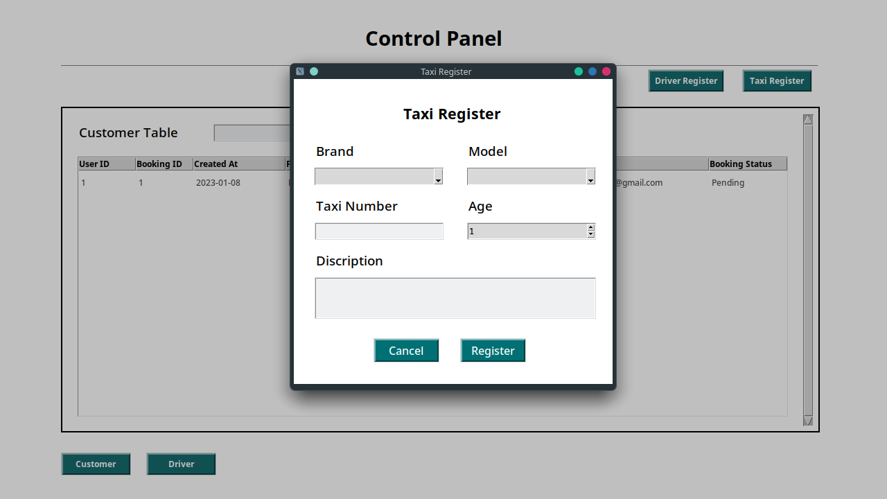Figure 33: register_taxi

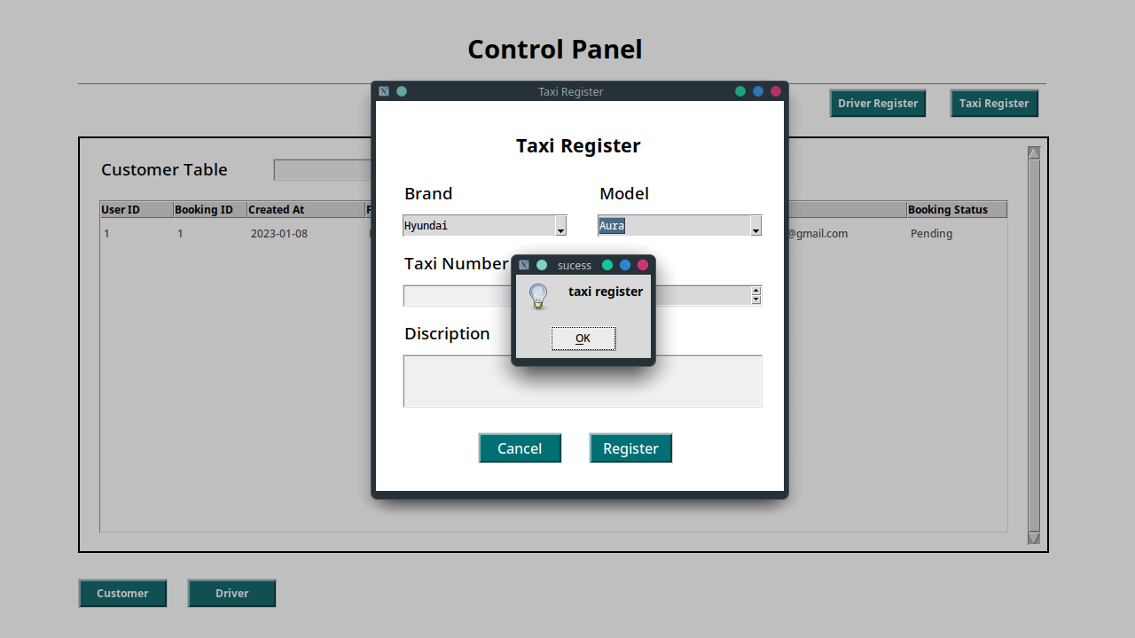Figure 34: after_clicking_on_taxi_register

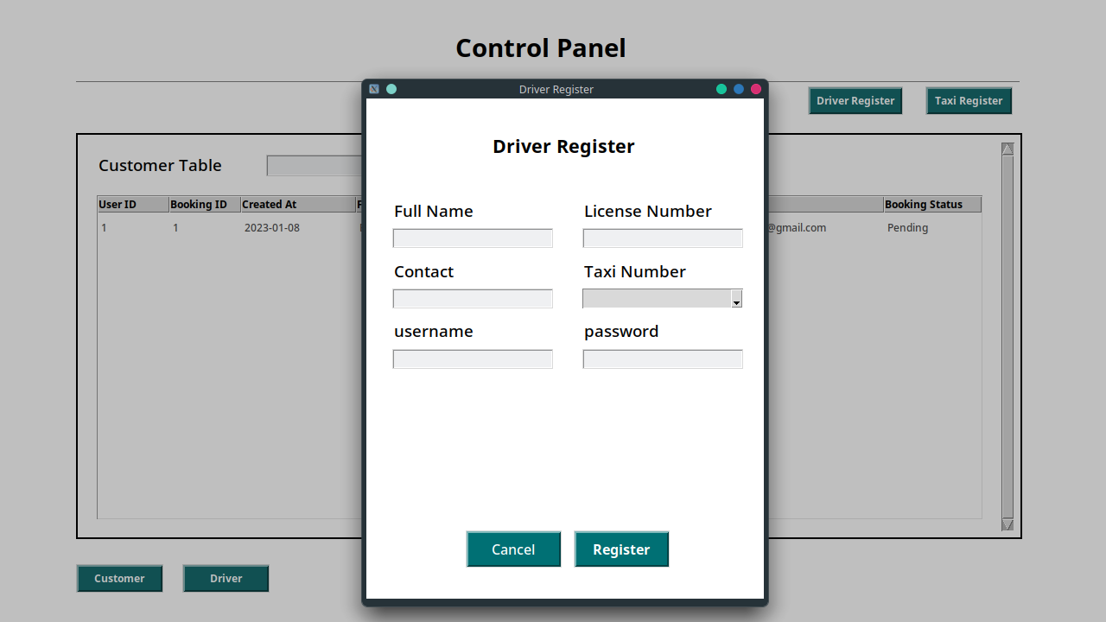Figure 35: driver_register

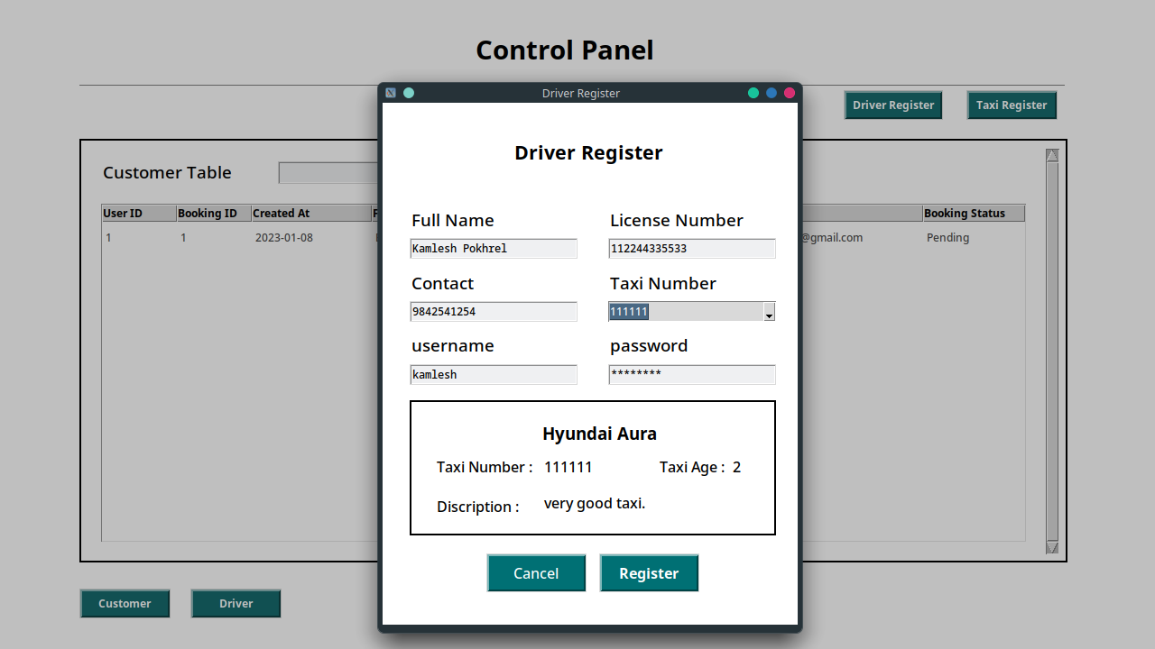Figure 36: driver_register_with_data

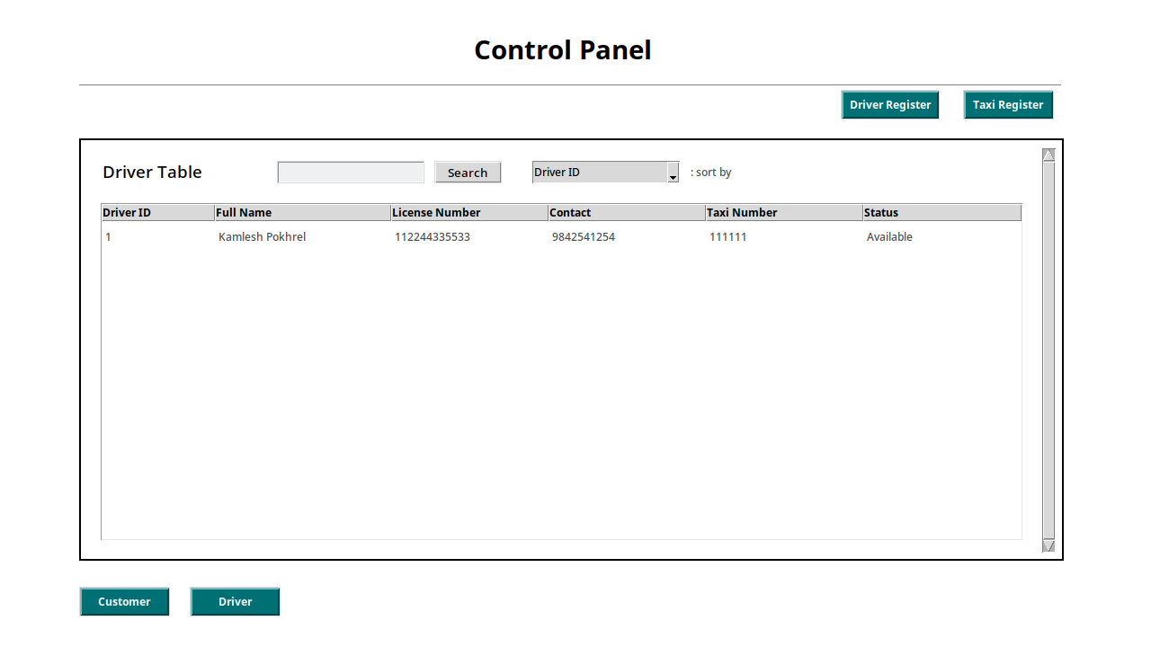Figure 37: after_driver_is_registered

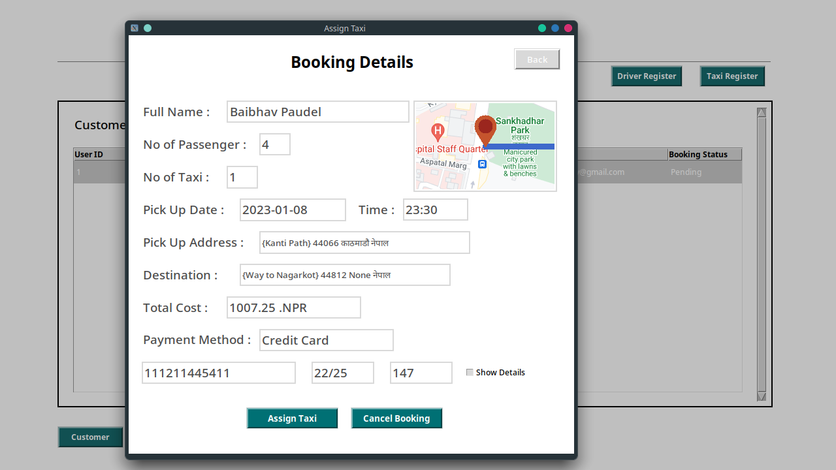Figure 38: double_clicking_on_booking_request

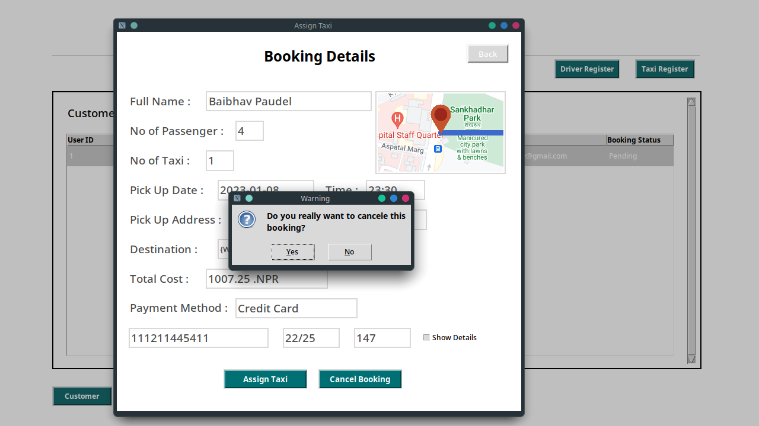Figure 39: after_clicking_on_cancel_booking

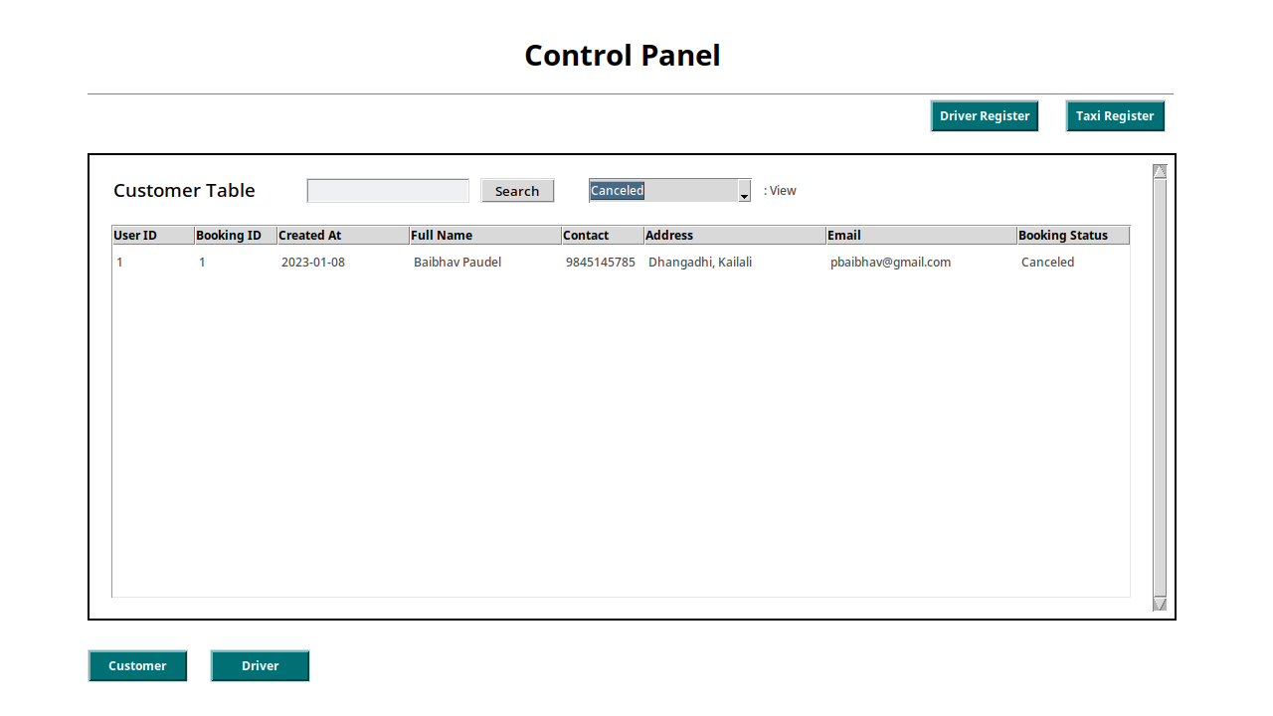Figure 40: after_booking_is_canceled

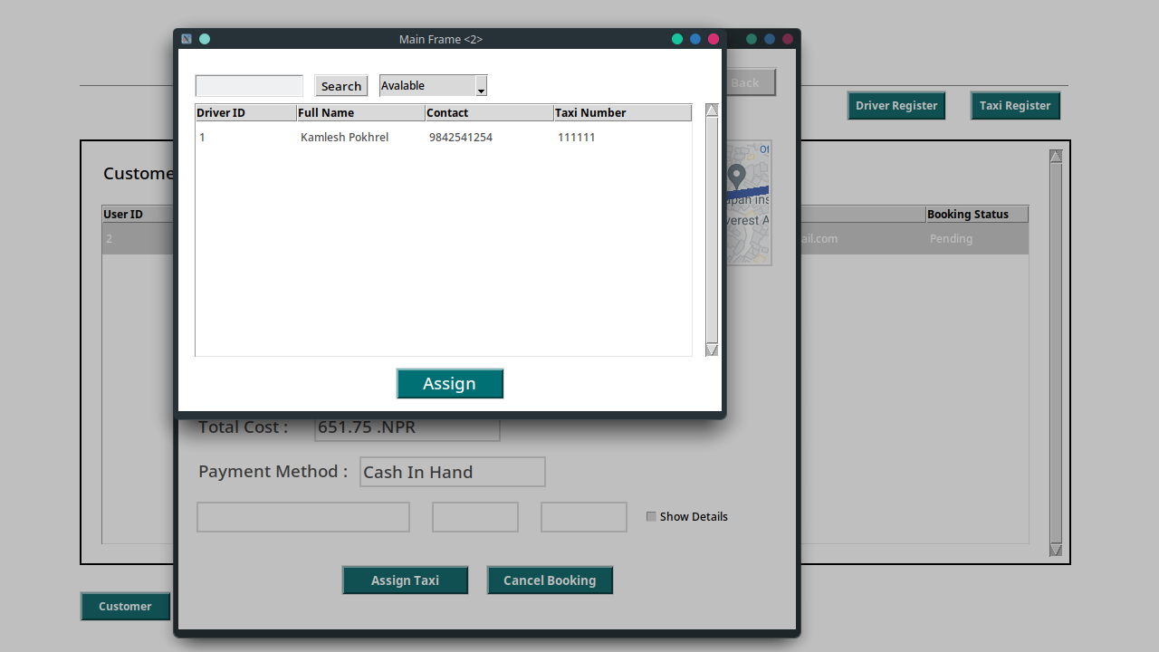Figure 41: after_clicking_on_assign_button

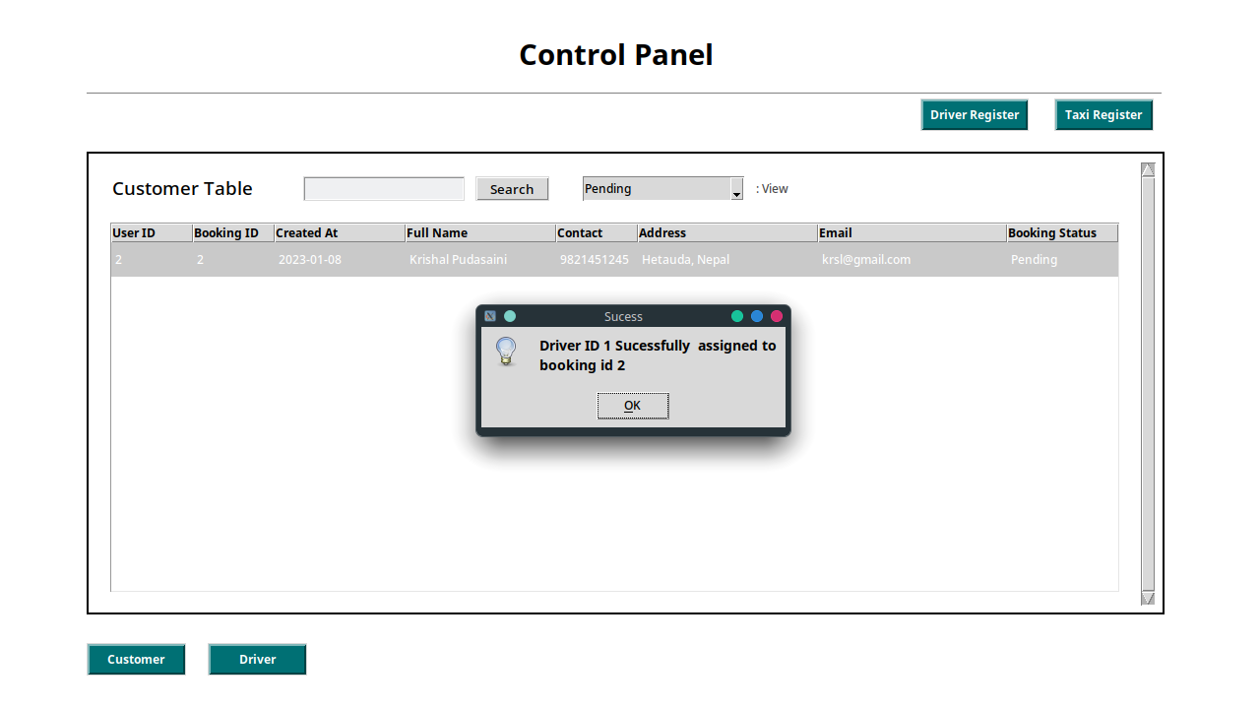Figure 42: after_clicking_on_register

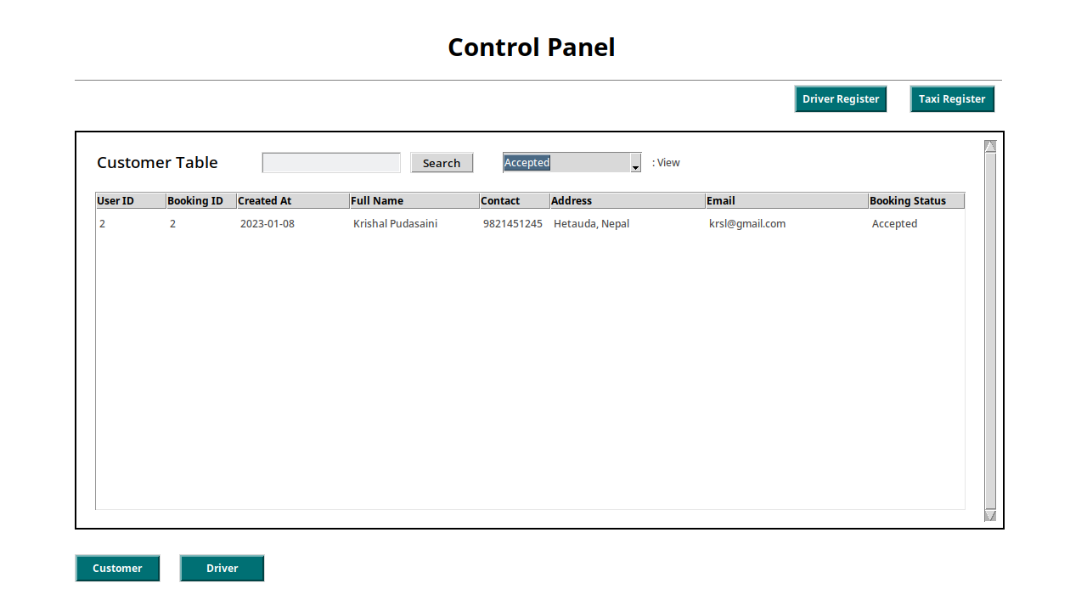Figure 43: booking_detail_after_booking_is_accepted

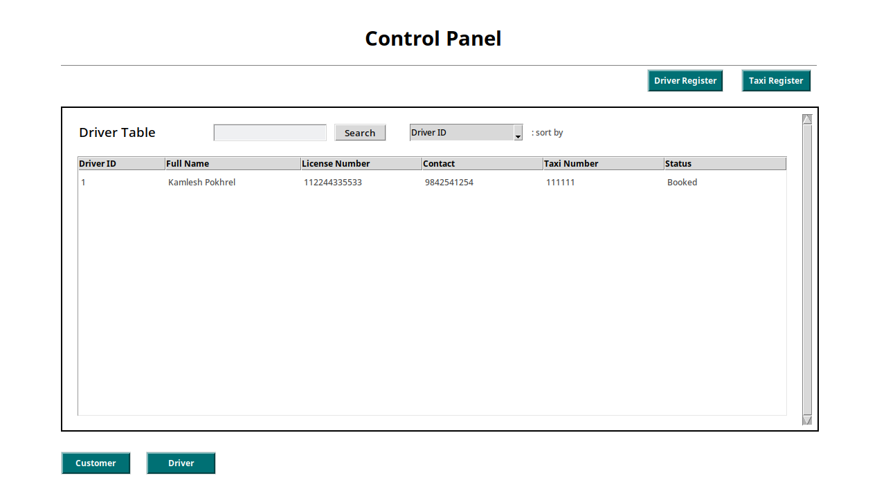Figure 44: driver_detail_after_booking_is_accepted

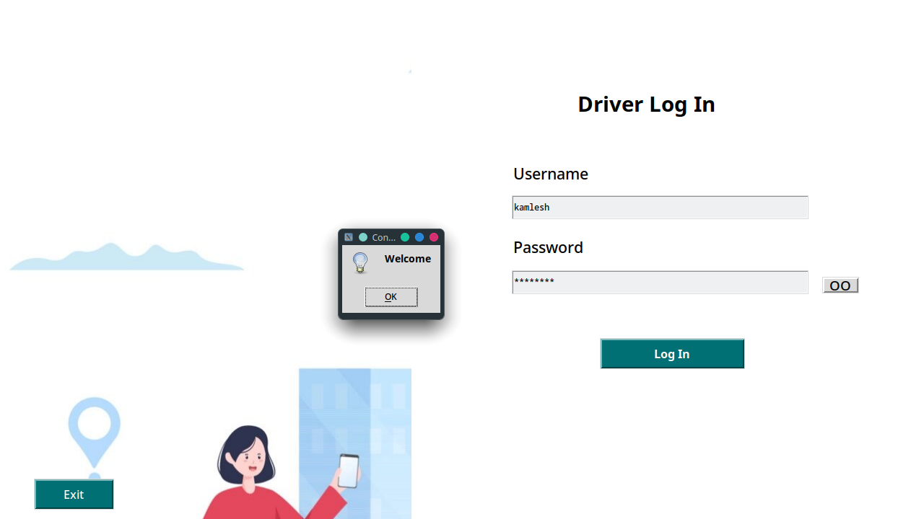Figure 45: driver_login_page

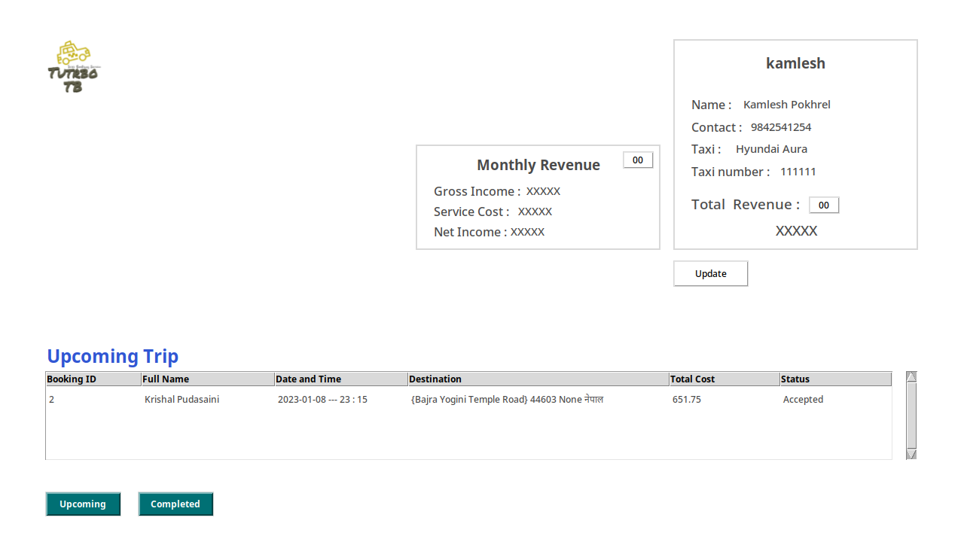Figure 46: driver_dashboard

**Remaining…..Photo : double click on booking request, after completed clicking on completed photo**

What rDBMS did you use? Possibly, SQLite, MySQL. Justify your choice of database system.

Did you use WAMP / XAMPP / MAMP or an equivalents stack on your own PC?

Detailed discussion of your experience coding is required here.

Did you incorporate any novel approaches to coding and meeting the Assignment requirements?

Testing

Include evidence of detailed and robust testing.

There are various ways to document this…

Test Plan / Test Log (tabular format) with date, input/expected output/actual output and screen shot of result.

OR

Documentation of each test – one after the other

You need to include:

* Test No
* Test Date
* Purpose of test
* Input data or action
* Expected result
* Actual result
* Action if the above are not the same
* Screenshot of output

Discussion / Reflection / Critical Analysis

* What went well and what went wrong?
* What would you have done differently?
* How would you improve your application in the future?

This part is very important. You must discuss the project, group work, and time management skills.

Basically, you are evaluating what you have done. Did you achieve all the required specification of the Assignment brief? If not, why not? Discuss the problems you encountered and how you overcame them.

What stopped you achieving what you had hoped to achieve and to the standard you know you are capable of achieving? Remote learning, lack of access to BREO, COVID, lack of suitable devices remotely, Internet connection issues etc.

Did you give yourselves enough time to accomplish this work? Was it harder than you expected? What have you learned from tackling this Assignment?

If working as a group, did your group work well together? What did you learn about the dynamics of group work?

Did this work enhance your understanding of the Python programming language? Did it motivate you to learn more Python, and other programming languages?

If you had to undertake this or something similar again would you tackle it differently?

What improvements or enhancements would you recommend for a future iteration of this project?

Conclusion

What were you asked to do? Did you achieve it?

References

Use the Harvard Referencing System. Any reference must be cited in text -otherwise it should go in a Bibliography section.

Appendix

Make sure that all content has a Fig. No., caption and explanation.

You MUST include:

Complete project code.

Include file/class names.

Make sure you code is fully commented and well presented with correct indentation and colour coding.

You could include:

Details of you database/table structure and content (from PHPMyAdmin / SQLite Studio)

Screen shots of your GUI or text-based interfaces

Anything else that you might want to include which does not fit well into the main report body.